# 

# **ELECTRONIC PLAN OF STUDY (EPOS) GUIDE**

(Adapted from OGSPS EPOS Guide)

## **Student Instructions**

* Read the Electronic Plan of Study Guide
* Review the “Other Tips” at the end of this document
* Once you’ve drafted your Plan of Study, please “**Submit as Final”** (can still make changes to the plan, as needed) so that the AAE Graduate office can review. If any changes are needed, the plan will be returned to you for editing.

All degree seeking graduate students are required to submit an electronic plan of study (EPOS) as soon as possible in their program. This EPOS serves as a contract between the student, their advisory committee, and the OGSPS. It lists the courses that the student expects to take for the degree program, any concentration(s) the student is pursuing, the faculty members who will mentor them throughout their study and other key degree-related items.

**The School of Aeronautics and Astronautics requests that MS students submit an initial plan of study before registering for the second semester, and PhD students submit the plan of study before registering for the third semester. Students can submit future changes to the initial plan later and as needed.**

For information on OGSPS regulations, see [Section X](http://catalog.purdue.edu/content.php?catoid=8&navoid=8246) of the University Catalog (Purdue University, 2017)

## **Building the EPOS**

Before you begin, it is recommended that you discuss with your advisor aspects of your plan, such as the courses that should be included, the individual(s) who should be a part of the advisory committee (MS thesis and PhD), and any transfer courses or master’s credits to be used (if applicable). Once you have an outline of the courses and committee, follow Steps 1-12 below to begin building your EPOS. Please reach out to AAE Grad Office ([aaegradoffice@purdue.edu](mailto:aaegradoffice@purdue.edu)) should you have any questions.

1. **Login to** [**myPurdue**](https://mypurdue.purdue.edu/) **using your Purdue career account credentials. Under the “Academics” tab, select the “OGSPS Plan of Study” link in the “Graduate Students” card.**

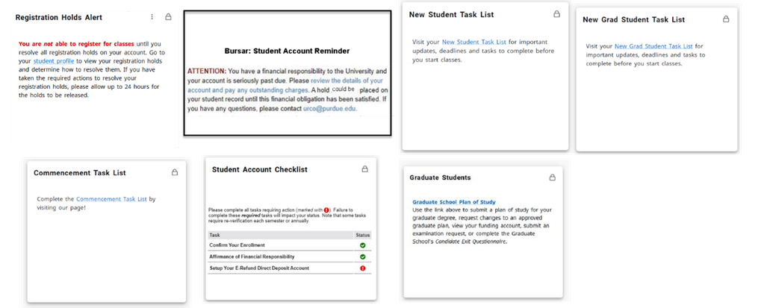

1. **Login using your Purdue career account credentials.**

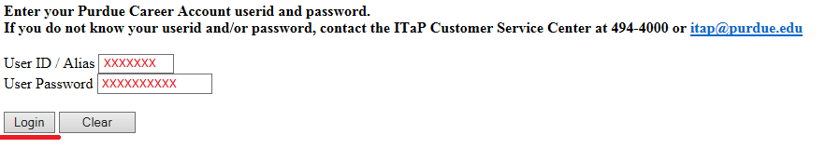

1. **Click the “Plan of Study Generator” link.**

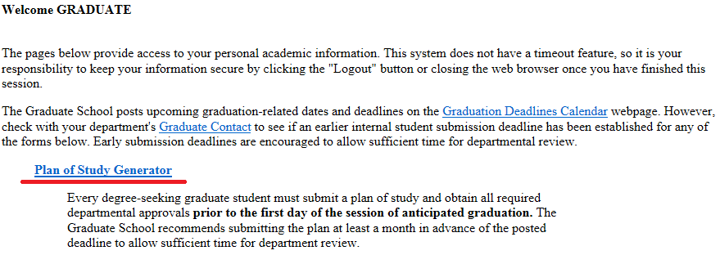

1. 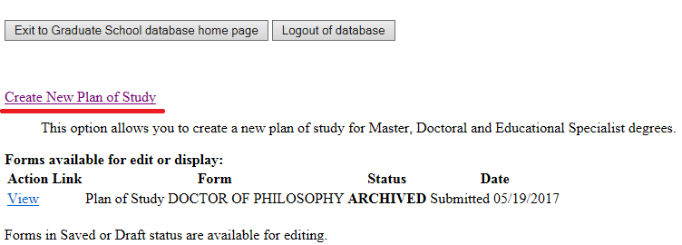**Select “Create New Plan of Study.”**

*Note on Creating a New Plan: If you have a plan in “Saved” or “Draft” status, you should see an “Edit” link to the left of that plan. Please use that link to re-access the existing form rather than begin a new plan. Only one saved or draft plan can exist in the system at a time.*

1. 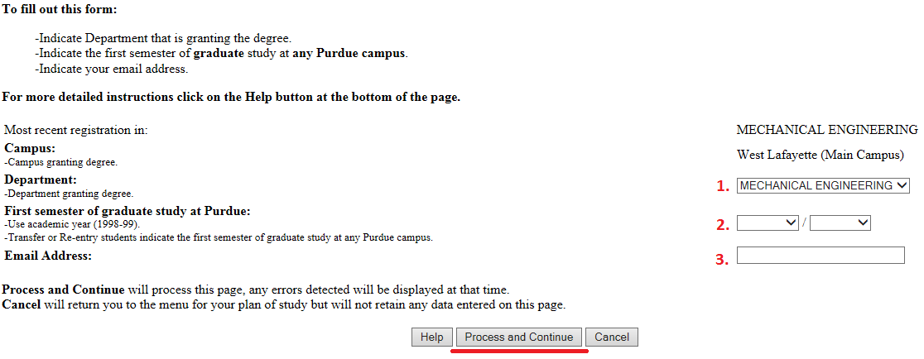**Select the department that will be responsible for awarding this degree, choose your first session of study in this program, and enter your email address. Once all fields have been completed, select “Process and Continue.”**

*Explanation of Purdue’s Academic Calendar: The academic calendar at Purdue begins with the fall session. Fall 2017 should be entered as “Fall/2017-18.” Spring 2018 should be recorded as “Spring/2017-18.” Summer 2018 as “Summer/2017-18.”*

1. **Select the degree for which this plan is being created, specify whether this is for a thesis or non-thesis degree, and choose your estimated date of degree completion. If you are pursuing a doctoral degree, leave Step 2 blank. Once all fields have been completed, select “Process and Continue.”**

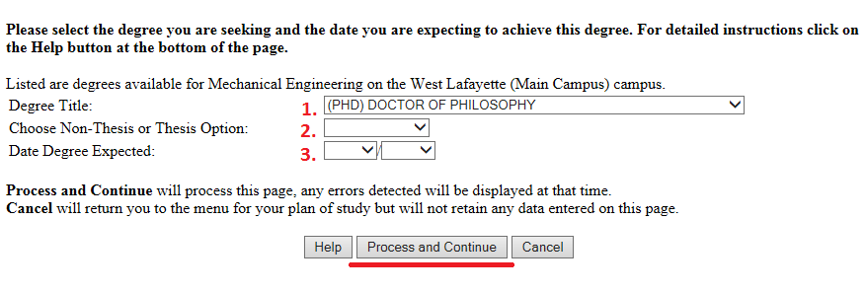

*Note on “Degree Title” Field: The “Degree Title” drop-down will automatically display all degree options available within the department, regardless of your current classification.*

*Note on Date Degree Expected: The date listed in the 3rd drop-down above is just an estimate. Though this date is helpful to those reviewing the form, students will NOT automatically be added as candidates in the session listed.*

1. **This second “Process…” button creates the plan, and places it in “Saved” status. To adjust the information entered during Steps 5-6, select the first “Student and Degree Information” link.**

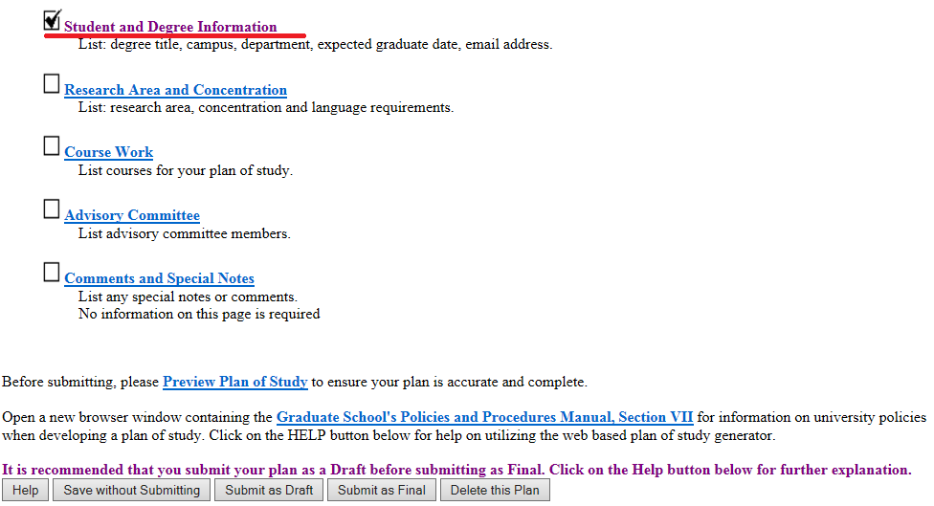

1. **Click the “Research Area and Concentration” link (the second link shown in Step 7).** 
   1. **Research Area:** Type in your primary focus area from the list provided- (Aerodynamics, Aerospace Systems, Astrodynamics and Space Applications, Autonomy and Control, Propulsion or Structures and Materials)
   2. **Concentration:** This is only for those pursuing, and have been approved to join, a specialized concentration area such as Engineering Leadership (Professional MS program) or Computational Engineering. If applicable, select the concentration from the list. If not applicable, leave it blank.
   3. **Language Requirement:** Leave blank**.**
   4. **When all required areas have been completed, click “Process and Continue.”**

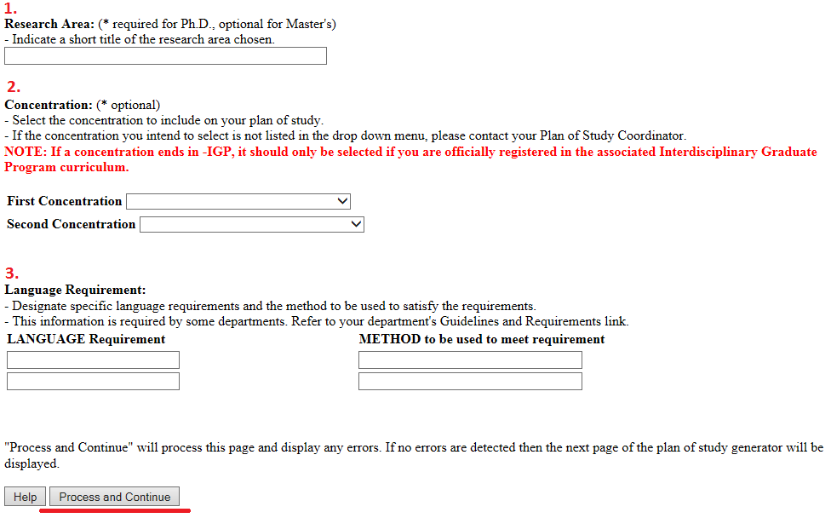

1. **Click the “Course Work” link (the third link shown in Step 7). Use one or more of the following four links to add the courses you expect to use exclusively for this degree. When all courses have been added, click “Process and Continue” to return to the main screen shown in Step 7.**

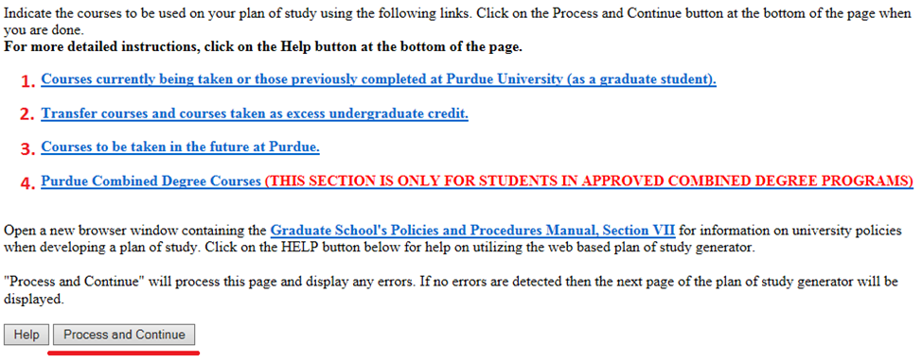

**For MSAA students, the courses in your primary area of focus should be labeled as “primary” and all others as “secondary,” while the PhD plan of study should just indicate all courses as “primary.”**

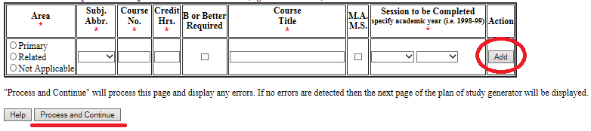

**Transfer Courses:** If you have courses to transfer from another institution to Purdue, select the second “Transfer courses…” link on the main course page. Transfer courses must be “B” or better equivalent, not used for a degree elsewhere, and graduate level. Courses should be added exactly as they appear on the transcript from that institution and should have already been reviewed by the AAE Graduate Office before adding to the plan of study. When done, select “Process and Continue.”

**Courses to be taken in the future at Purdue:** Using the third “Courses to be taken in the future…” link on the main course page. Enter the information exactly as it will appear on the Purdue transcript. Once all courses have been added, select “Process and Continue.”

**Purdue Combined Degree Courses (for AAE BS/MS students ONLY):** If you are in an approved combined degree program, use the “Purdue Combined Degree…” link from the main course screen to add the 500-600 level courses to be dual counted between the Purdue undergraduate and graduate degrees. Once these dual courses have been added, click “Process and Continue.”

*Note: You will need to be sure the courses listed manually in this section are also unselected in the current ‘Courses currently being taken…” section.*

*PhD Coursework Note: If you are creating a doctoral plan, do not use this “Course Work” area to add courses that were used for a previous awarded master’s degree. Up to 30 credits from an awarded master’s may be used toward the 90+ credits required for a doctoral degree, but approved master’s credits will be listed by your department after you submit your plan.*

1. **Click the “Advisory Committee” link (the fourth link shown in Step 7). For each member of your committee, designate the participation level of that member in the first column, enter their department code and faculty ID, and then click “Add.” In AAE, MS thesis committees require at least three members, PhD committees require at last four, and MS non-thesis only require one.**

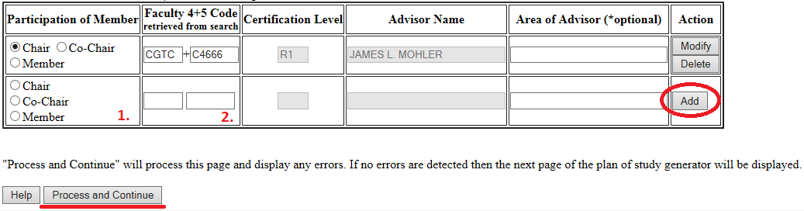

*Additional Explanation for Adding Committee Members to a Plan:*

* *Committees may have one person designated as “Chair,” or they may have two who are both designated as “Co-Chair.”*
* *If the department or ID code are not known, use the search faculty search function at the bottom of this page to look up active faculty by department.*
* *With the exception of non-thesis advisory committees in departments that allow just one member, at least 51% of the committee must hold “R” level faculty certification levels. The “R” and “S” distinctions are noted in the “Certification Level” column above.*

1. **If you have any notes that you would like to add to this plan (e.g. the number of research credits you expect to take, approved substitutions, or master’s coursework), click the “Comments and Special Notes” link shown in Step 7. Once the note has been added, click “Process and Continue.”** 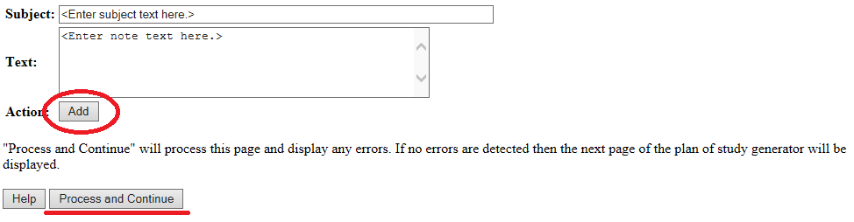

*AAE requests the following notes:*

1. **Once there are “checks” in the boxes to the left of the first four links, the plan is** **eligible to be submitted for department and OGSPS review. Please “submit as final” so the plan can be reviewed by the AAE Graduate Office.**

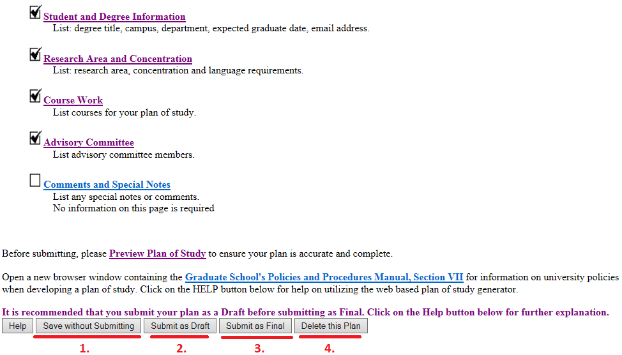

*Explanation of the Gray Buttons on the Home Page for “Saved” or “Draft” Plans:*

* *Click “Save without Submitting” to preserve the information entered for editing at a future time. Plans in “Saved” status may be accessed by either the student or plan of study coordinator.*
* *Click the “Submit as Draft” if you are not finished filling out your plan of study.*
* *If all key components have been included on the plan, click “Submit as Final.” This button will submit the plan for signature. Students must submit their plan as “Final” and receive all department signatures on the form before the start of the session of anticipated graduation. Doctoral students must submit their plan prior to scheduling a preliminary examination for the doctoral degree. For specific dates regarding graduation, see the Graduation Dates and Deadlines Calendar (OGSPS, 2017).*
* *Selecting “Delete this Plan” will completely remove this plan from the system. Deleted plans cannot be re-accessed. If a new plan is needed, one will need to be initiated from the beginning.*

## **References**

*Purdue University (2017). University Catalog: Policies & Procedures for Administering Graduate Student Programs. Retrieved June 2, 2017, from http://catalog.purdue.edu/content.php?catoid=8&navoid=8285.*

*Purdue University OGSPS (2017). Graduation Dates & Deadlines. Retrieved June 4, 2017, from http://www.purdue.edu/gradschool/about/calendar/deadlines.html.*

## **Other tips for putting together a plan of study:**

**Course Planning**

While the next semester’s schedule may be available soon, to predict what will be available for your plan of study in terms beyond the next semester, there are two things you can do.

Visit the [Purdue Online Course Projections](https://engineering.purdue.edu/online/courses/list?query=ME%7C%7CFall%202025&type=and). While this is most helpful for online students, most of the courses will have a corresponding in-person section, so this is also a helpful tool for residential students. For many of the courses you can find detailed course descriptions, recommended prerequisites, example syllabi, etc.

Look at previous schedules in myPurdue. For example, if you’re trying to predict what might be available in Fall 2026, look at the Fall 2024 schedule, as it is likely to be the most like the next fall of an even year schedule. This method won’t capture new courses, or offerings that don’t follow a regular cadence, but in that case, you can submit changes to your plan of study as needed, and as official semester schedules are released.

**Faculty Advisor (Chair)**

All students will need at least one professor listed on the plan of study to approve coursework and to lend any course selection advice to you. This should be a professor that’s in your area of focus. You can reach out to a professor you may have had in class or refer to our faculty list by area available on our website. It is recommended to reach out via email, or visit office hours, to briefly introduce yourself, ask if you can put them on your study non-thesis plan, and/or arrange a time to ask any questions about courses/advice.

For thesis-track students, the faculty advisor is also your research advisor. Faculty availability varies and some may not have the availability/capacity to accept a thesis student. If this is part of your plan to do research but you haven’t found a thesis advisor, you may need to submit a temporary non-thesis plan with a willing non-thesis faculty advisor while you continue to find a thesis advisor.

For PhD and MS thesis students, the members needed to complete your committee should be discussed with your faculty advisor (Chair). Refer to the committee guidelines in the [Rules and Regulations](https://engineering.purdue.edu/AAE/academics/graduate/rulesguidelines).